Students Placements-IQR,1.5rule,Lesser,Greater,Min,Max

The table seems to be related to data preprocessing, possibly for a dataset with columns named "sl_no," "ssc_p," "hsc_p," "degree_p," "etest_p," "mba_p," and "salary

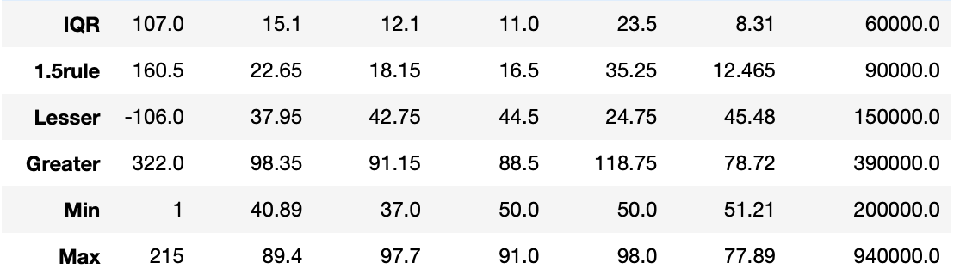

1. IQR (Interquartile Range):

IQR is a measure of statistical dispersion or spread. It is used to describe the range between the first quartile (Q1) and the third quartile (Q3) in a dataset.

2. 1.5 Rule (1.5 * IQR):

The 1.5 Rule is a common method for detecting outliers in a dataset. It involves multiplying the IQR by 1.5 and adding it to Q3 or subtracting it from Q1.

3. Lesser:

The "Lesser" values indicate the lower thresholds for potential outliers in each column.

Any data point in a column that is less than the "Lesser" value is considered a potential outlier on the lower end.

4.Greater:

The "Greater" values indicate the upper thresholds for potential outliers in each column.

Any data point in a column that is greater than the "Greater" value is considered a potential outlier on the higher end.

5. Min:

The "Min" values represent the minimum values in each column

These values provide a range for the entire dataset in each column.

6.Max:

The ""Max" values represent the maximum values in each column.

These values provide a range for the entire dataset in each column.